CELLULARLINE’S NEW EARPHONES LINE-UP IS COMING

UNDER EMBARGO UNTIL 06 SEPT 9 AM

Comfort, versatility and functionality are the keywords

Cellularline S.p.A., the European leading company in the development and sales of accessories for smartphones and tablets, showcases at IFA 2019 (6-11 September 2019) a variety of products dedicated to the smartphone’s users who are always on the move.

Two mono earphones and a headset with TWS Technology are the main protagonists of the new line-up as they keep the user's level of attention high by ensuring the right perception of the surroundings. The new earphones are practical and functional as they are designed for frequent telephone’s users who are often in situations in which having both hands free is essential for security.
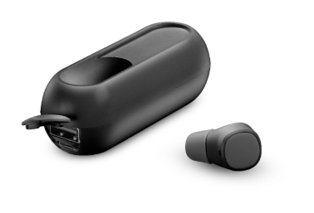
MONO POWER MINI HEADSET
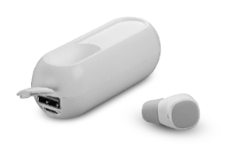
The Bluetooth mono in-ear headset is perfect if you are looking for comfort and flexibility without giving up on style. While the microphone complete with answer button allows to easily answer to phone calls, the multi-function button enables to manage music and phone calls with no confusion. The case can charge directly the headset at any moment with up to 50 hours of autonomy, and it operates as power bank for smartphones as well. Mono Power Mini Headset is provided with
IPX6 certificate and it is sweat and water resistant.
Available in white and black.
Price: € 29,95

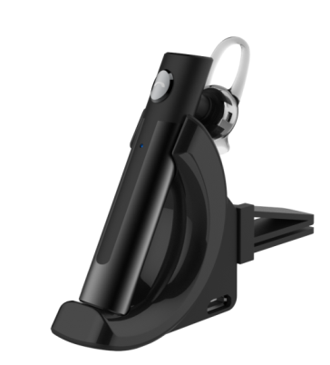
MONO CAR MAGNET HEADSET
The Bluethooth mono car magnet headset is able to perfectly adapt to any type of ear with the maximum stability and comfort.
It’s the perfect accessory for those who are always on the move and it’s extremely easy to use thanks to the microphone with answer button which allows to nimbly answer phone calls, together with the touch control system which enables to adjust the volume. Thanks to the micro USB port it is possible to charge the earphone without using the charging base.
Price: € 29,95

UNDER EMBARGO UNTIL 06 SEPT 9 AM
TWS JAVA
TWS JAVA are the smallest and the most versatile earphones equipped with True Wireless Stereo technology, which allows to connect them to your device in total freedom of movement. The elegant charging case is solid and compact and can fit the palm of your hand while charging the earphones up to three times. The microphone complete with answer button enables to easily answer your phone calls. The Touch Control System is key to handle music, phone calls and voice assistants like Siri or Google Now.
Available in white, black and pink.
Price: € 59,95

About Cellularline S.p.A.
Cellularline S.p.A. is the leading company in the accessories’ market for smartphone and tablet. Cellularline brand is the technological and creative landmark concerning the accessories for multimedia devices and aims to offer excellent performances and easy-to-use products for a unique user’s experience. Currently, Cellularline S.p.A. counts about 200 employees and boasts an intercontinental distribution in over 60 countries.

INTERNATIONAL PRESS CONTACTS: SAY WHAT? Srl (Milan, Italy)
Geraldina Soldadino, Senior Account Manager Media Relations: g.soldadino.cons@saywhat.it, Mob. + 39 388 3938334
Letizia Castiello, Junior Account Media Relations: l.castiello@saywhat.it, Tel. +39 02 3191181

PRESS CONTACTS BELGIUM: EVOKE (Etterbeek, Belgium)
Gilles Dujardin, PR Consultant : gilles@evokepr.be, Mob. +32 474 818 999
Ymke Deprez, PR Consultant : ymke@evokepr.be, Mob. +32 479 75 52 32

